US Med-Equip Target Solution Architecture
Detailed Future-State Recommendation: Ascent Rental / Salesforce Native Core, Offline Field Mobility, Billing, Financials, Tax, Analytics, PHI Tokenization and Invoice Presentment
Working Architecture Document | August 2026
Architecture selection. Ascent Rental is the selected rental-management solution. The target design consolidates commercial, rental, asset, inventory and basic field-service operations on Salesforce while retaining GoTransverse for authoritative billing in Year 1, Acumatica for accounting, Avalara for sales tax, and Snowflake/Power BI for analytics.

1. Executive Summary
USME intends to move to a Salesforce-native operating model centered on Ascent Rental. The current Salesforce Sales Cloud environment is the source for customers, opportunities, quote-to-order and contracts. In the target state, those commercial processes and the rental/asset operating model are managed in the Ascent/Salesforce platform. Experience Cloud is separately licensed for hospital and partner self-service.
- Ascent Rental / Salesforce becomes the primary operational system of record for customer, opportunity, quote-to-order, contracts, product catalog, pricebooks, rental and sales orders, serialized assets, install base, inventory, warehouse-lite, operational purchase orders, work orders and preventive-maintenance history.
- Resco or Youreka is used as the offline mobile extension because the vendor response states that Ascent does not currently support offline operation for field service technicians with later synchronization. The extension provides offline work-order execution, preventive maintenance (PM) checklists, barcode capture, photos/signatures and synchronized completion.
- GoTransverse (GT) remains the authoritative billing and invoice-calculation engine during at least the first year. Ascent billing rules run in parallel as a shadow calculation so Finance can compare Ascent and GT results before any future billing-engine system decision.
- Acumatica remains the accounting/GL platform. Operational purchasing (POs), inventory/fleet accounting events and finalized GT billing transactions are interfaced into Acumatica using controlled mappings and reconciliation.
- Avalara is the centralized sales-tax engine for rental, sale, buyout, service/PM, parts and other taxable charge types. GT commits tax for authoritative invoices; Ascent can use the same tax inputs for quote/shadow calculations without creating duplicate committed tax transactions.
- Salesforce remains the PHI boundary and invoice presentment repository. GT receives an opaque token instead of patient identity; final GT invoice values return to Salesforce, where the token is resolved to protected billing context, the PHI-bearing PDF is rendered, versioned and stored for internal users and Experience Cloud users.
- Salesforce Shield is the primary Salesforce security enhancement for PHI protection: Platform Encryption, Event Monitoring, Field Audit Trail and Data Detect are combined with least privilege, external-sharing controls, sandbox masking and mobile-device controls.
- Snowflake receives governed, incremental data from Ascent/Salesforce, GT, Acumatica and Avalara. Power BI consumes certified Snowflake models; Snowflake is analytical, not a transaction-processing system.

2. Source Basis and Fit-Driven Architecture Decisions
This revision is based on the prior USME target-architecture document, the functional requirements, the additional data-ownership notes, and the Ascent vendor response dated August 2026. The vendor response materially changes the architecture because Ascent is Salesforce-native: CRM/commercial, rental, asset and work-order records can reside in one platform rather than being synchronized between Salesforce and a separate rental application.
Vendor response area | Observed fit | Architecture response
Rental activation / termination (C6, C9) | Standard | Use Ascent state changes as the authoritative operational triggers for deterministic GT billing-start and billing-stop events.
Fulfilment orchestration (C3) | Extension / roadmap | Make delivery work-order orchestration an implementation design item with scripted POC and regression tests; avoid broad custom code outside standard Salesforce Flow/Ascent extension patterns.
Inventory allocation / dynamic reallocation (C4) | Partial | Use standard rental master/order capability for reservation; configure invocable/Flow-based reallocation only where business value justifies it and maintain an exception queue.
Offline mobile (D4) | Not supported natively today | Use Resco/Youreka offline mobile extension; keep Ascent as the system of record and constrain local mobile data to the minimum needed for assigned work.
Dispatch / scheduling (D2, E3) | No native dispatch optimization | Use simple territory/ownership assignment in Salesforce for baseline operations. Treat advanced route/optimization as optional future FSM capability rather than hidden customization.
Substitution (D7) | Custom | Implement controlled equivalency rules and reason codes as a scoped extension, not free-form technician substitution.
Lost equipment / consolidated charges (E6, E10) | Custom / mixed | Use a canonical charge-event model so loss, damage and parts are normalized before GT; prevent each custom process from inventing a separate billing integration.
Procurement (H5) | Standard / configuration | Ascent owns operational PO creation and approval; approved PO and receipt events flow to Acumatica for AP/financial accounting.
Shipping / freight (H7) | Third party | Keep ZenKraft/Bringg or equivalent optional and interface only if USME needs carrier/tracking automation beyond Ascent warehouse-lite.
Equipment swap (G7-G8) | Core + configured automation | Use Ascent as the authoritative atomic asset/install-base swap process, with billing continuity controls and no duplicate active assignment.
Signature (G9) | JunoDoc / existing stack / custom flow | Prefer capture in the selected offline mobile extension when possible to avoid adding another mobile dependency; preserve completion evidence in Salesforce.
Opportunity / case capabilities (H1, G1) | Salesforce standard objects assumed | Confirm Ascent/OEM Salesforce entitlement permits the required Opportunity and Case/Service features. Retain targeted Sales/Service Cloud licenses if standard-object entitlements are not included in the Ascent-provided license.

Licensing dependency - validate before contract finalization. The vendor response assumes standard Salesforce Opportunity and Service Cloud Case capabilities. USME should obtain written confirmation of the exact Salesforce OEM/Platform entitlements bundled with Ascent. If Opportunity, Case, Email-to-Case or required service features are not covered, retain only the incremental Sales/Service Cloud licenses required.

3. Target Architecture Principles
Principle | Application to USME target state
Salesforce-native operational core | Customer/commercial and rental operations should share one Salesforce data model wherever the Ascent package supports the requirement. Do not recreate a Salesforce-to-rental synchronization boundary that the native architecture removes.
Native/configuration first | Use Ascent standard capability and Salesforce configuration before approving custom Apex/LWC. Extensions are justified for documented fit gaps such as dynamic reallocation, substitution, specific lost-equipment workflow or targeted orchestration.
One authority per business state | Ascent owns operational rental/asset/work-order state; GT owns Year-1 billed financial output; Avalara owns tax determination; Acumatica owns GL/accounting; Salesforce owns protected PHI mapping and invoice presentment; Snowflake owns analytical copies only.
Billing-event integrity | Every activation, termination, service, loss, damage, buyout and adjustment event has a unique source event ID, effective timestamp, correlation ID and processing status.
Minimum necessary PHI | Even though Ascent is in the Salesforce org, rental, inventory, offline-mobile and integration records should carry tokenized/minimum-necessary patient context by default. GT, Acumatica and Avalara should not receive patient identity unless separately approved and necessary.
Financial immutability | Salesforce does not recalculate finalized GT invoice values. Corrections are processed in GT and return as explicit credit, void, rebill or adjustment versions.
Connectors are accelerators, not architecture | Available Salesforce connectors may be used, but system-to-system logic is governed through a canonical iPaaS/event layer with consistent retry, security, monitoring and reconciliation.
Shadow billing has no financial authority | Ascent parallel billing is a comparison/control mechanism in Year 1 and must not post customer invoices, GL, tax commitments or cash transactions.
Analytics is downstream | Operational users transact in Salesforce/Ascent, GT and Acumatica. Power BI reads curated Snowflake models and is not used to update source-system state.
Security by layer | Shield protects Salesforce PHI and auditability; Experience Cloud sharing isolates customers; mobile offline data is encrypted/managed; integration logs exclude PHI; non-production environments use de-identified data.

4. Future-State Logical Architecture
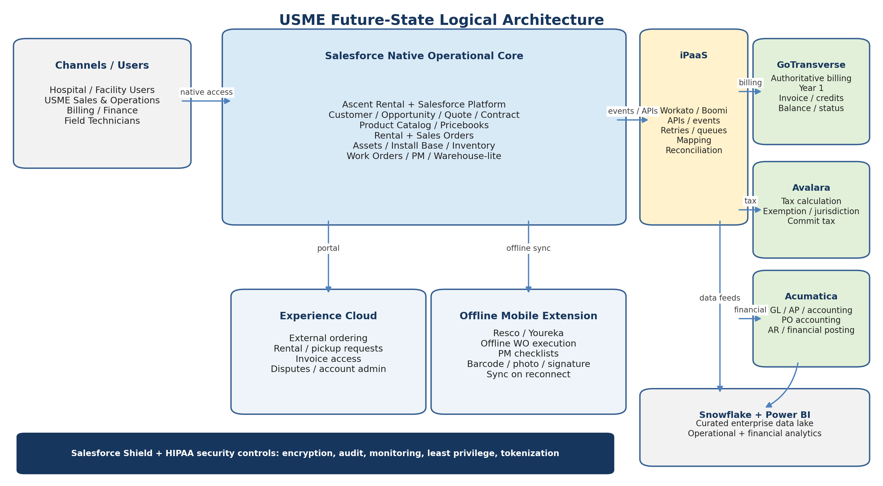
Figure 1. Salesforce-native future-state logical architecture.
The preferred deployment pattern is a single Salesforce org in which Ascent is installed into the current Salesforce environment, subject to package compatibility, technical-debt review and Ascent commercial terms. This preserves customer history, minimizes duplicate masters and allows Experience Cloud, Shield and native Salesforce automation to operate against the same records. A separate Ascent Salesforce org should be treated as an exception because it would recreate customer/contract/order integration and identity synchronization.
Component | Target responsibility | System-of-record role
Ascent Rental / Salesforce Platform | Customer, contacts, opportunity, quote-to-order, contracts, products, pricebooks, rental/sales order lifecycle, serialized/non-serialized inventory, asset/install base, warehouse-lite, operational POs, work orders and PM. | Primary operational system of record.
Experience Cloud | Hospital/facility portal identity, entitlement-based ordering, rental/pickup/service requests, order status, invoice access and permitted account administration. | Channel over Salesforce records; not a separate process engine.
Resco / Youreka mobile | Offline work-order/PM execution, barcode scanning, photos, signatures, checklists and later synchronization. | Transient offline execution layer; Salesforce remains authoritative.
GoTransverse | Rate execution, recurring billing, invoice number/lines, credits, adjustments, balance and payment status in Year 1. | Authoritative billing engine and invoice financial source.
Avalara | Sales/use tax calculation, jurisdiction, exemption handling and committed tax transaction. | Authoritative tax determination.
Acumatica | GL, AP, accounting, financial posting, vendor accounting, inventory/fleet accounting and financial reporting. | Authoritative accounting/ledger platform.
Workato / Boomi | Canonical mapping, event/API orchestration, queues, retries, replay, exception handling, monitoring and reconciliation. | Integration control plane; not a business-data system of record.
Snowflake | Conformed analytical history from operational and financial sources. | Enterprise analytical store.
Power BI | Rental utilization, service/PM, billing, finance, tax and executive reporting. | Presentation/analytics only.
Salesforce Shield | Encryption, Event Monitoring, Field Audit Trail and Data Detect for the Salesforce environment. | Security/control capability, not a business system of record.

5. System-of-Record and Data Ownership Model
Data domain | Authoritative system | Key downstream copies / consumers | Design rule
Customer / hospital / facility | Ascent / Salesforce | GT, Acumatica, Snowflake, Experience Cloud | One enterprise Salesforce Account ID; downstream systems store cross-reference IDs, not independent golden records.
Contacts / portal identities | Salesforce | Experience Cloud; limited operational/billing contacts to GT/Acumatica if needed | Do not replicate broad contact/PHI data to financial systems.
Opportunity / quote / contract | Ascent / Salesforce | GT receives effective billing terms; Snowflake analytics | Commercial terms are effective-dated; GT executable rate configuration is derived from approved contract/pricebook terms.
Product catalog / pricebook | Ascent / Salesforce | GT product/rate-plan mapping, Avalara tax code mapping, Acumatica item/account mapping, Snowflake | Maintain controlled crosswalk for product, service, tax, GL and billing codes.
Rental / sales order | Ascent | GT billing events, Acumatica financial impacts, Snowflake | Ascent order ID is enterprise operational reference; GT invoice links back through order and token.
Serialized asset / install base | Ascent | Offline mobile, Acumatica accounting reference, Snowflake | One active assignment per physical asset; ownership type distinguishes USME fleet, customer-owned, sold/service-only and consigned assets.
Inventory / warehouse / vehicle stock | Ascent | Acumatica accounting events, Snowflake | Operational quantity/location in Ascent; financial valuation/posting in Acumatica.
Work order / PM history | Ascent | Offline mobile; GT for chargeable services; Snowflake | Mobile creates/updates assigned records but authoritative completion is committed to Salesforce after synchronization.
Billing Context / PHI-token map | Salesforce secure object | Token only to GT and other downstream systems | Cross-reference is PHI; encrypt, restrict and audit.
Billing rules | GT Year 1; Ascent shadow copy | Ascent comparison; Snowflake variance analytics | Business contract/price terms originate in Salesforce; GT remains execution authority until formal transition decision.
Invoice financial values | GT | Salesforce presentment, Acumatica accounting, Snowflake | Salesforce renders values returned by GT; no independent financial recomputation.
Final invoice PDF | Salesforce Files | Billing Console, Experience Cloud | Versioned PHI-bearing presentment copy; hash and GT invoice reference retained.
Sales tax | Avalara | GT, Salesforce display, Acumatica, Snowflake | Only one committed tax transaction per authoritative invoice.
GL / AP / accounting | Acumatica | Snowflake; status feedback to Ascent/GT | Acumatica owns accounting period, GL account, AP and financial posting status.
Enterprise analytics | Snowflake | Power BI | No operational write-back from analytics unless separately governed.

6. Ascent / Salesforce Application Architecture

6.1 Customer, commercial and order management
The target state makes the Ascent/Salesforce environment the operational home for the commercial lifecycle. Customer/hospital and facility accounts, contacts, opportunities, quotes, contracts, product catalog, pricebooks, rental orders and sales orders remain logically connected within Salesforce. This eliminates the need for an external rental application to receive a duplicate customer/contract master.
- Opportunity: lead/qualified demand, stage progression, quote/proposal, negotiation and won/lost outcome. A won opportunity creates or links to the appropriate rental or sales order path.
- Contract and pricebook: customer agreement, eligible models, rates, buyout rules, standby/consignment terms, PO requirements and other effective-dated commercial controls.
- Rental order: request by model/quantity, validation, reservation/allocation, delivery work, activation, mid-rental changes, pickup, return, loss/damage and termination.
- Sales order: standard sale, dropship, refurbished, rental buyout, rental-to-own and other approved sub-types, with ownership-transfer controls.
- Experience Cloud: external users initiate the same underlying Salesforce/Ascent transactions rather than creating a parallel portal database.

6.2 Rental, asset, inventory and warehouse-lite
Ascent owns serialized and non-serialized inventory, asset status/location, install-base assignment, reservation, rental availability, warehouse/vehicle locations, return/inspection state and utilization. The vendor response indicates standard or configurable coverage for activation/termination, consignment, grouped transactions, return, bundle validation, procurement, parts consumption and swap. The architecture therefore keeps these processes in Ascent and uses targeted extensions only for documented fit gaps.
- Asset lifecycle states should be standardized and auditable: available, reserved, loaded/in-transit, delivered, active rental, pickup requested, returned, cleaning/inspection, repair, quarantine, available, sold/retired.
- Install base / assignment stores customer/facility, contract/order, effective dates, rental status and assigned asset. One physical asset may have many historical assignments but only one active assignment at a time.
- Warehouse-lite covers receiving, transfers, picking/loading, vehicle stock, returns and barcode-based execution. It is not positioned as a deep WMS unless USME later identifies advanced labor, slotting or automation requirements.
- Operational purchase orders can originate in Ascent when demand cannot be sourced internally; Acumatica receives the approved PO and subsequent receipt/return events for financial accounting.

6.3 Basic field service and work-order model
Ascent work orders and Salesforce tasks are the operational field-service records. The vendor response supports work-order types, inspection, repair, parts, swap and closure controls, but explicitly states that native dispatch optimization is not present. The baseline architecture therefore uses Salesforce ownership/territory rules and simple dispatcher assignment, while the offline mobile extension executes work in the field.

7. Offline Mobile and Preventive-Maintenance Architecture
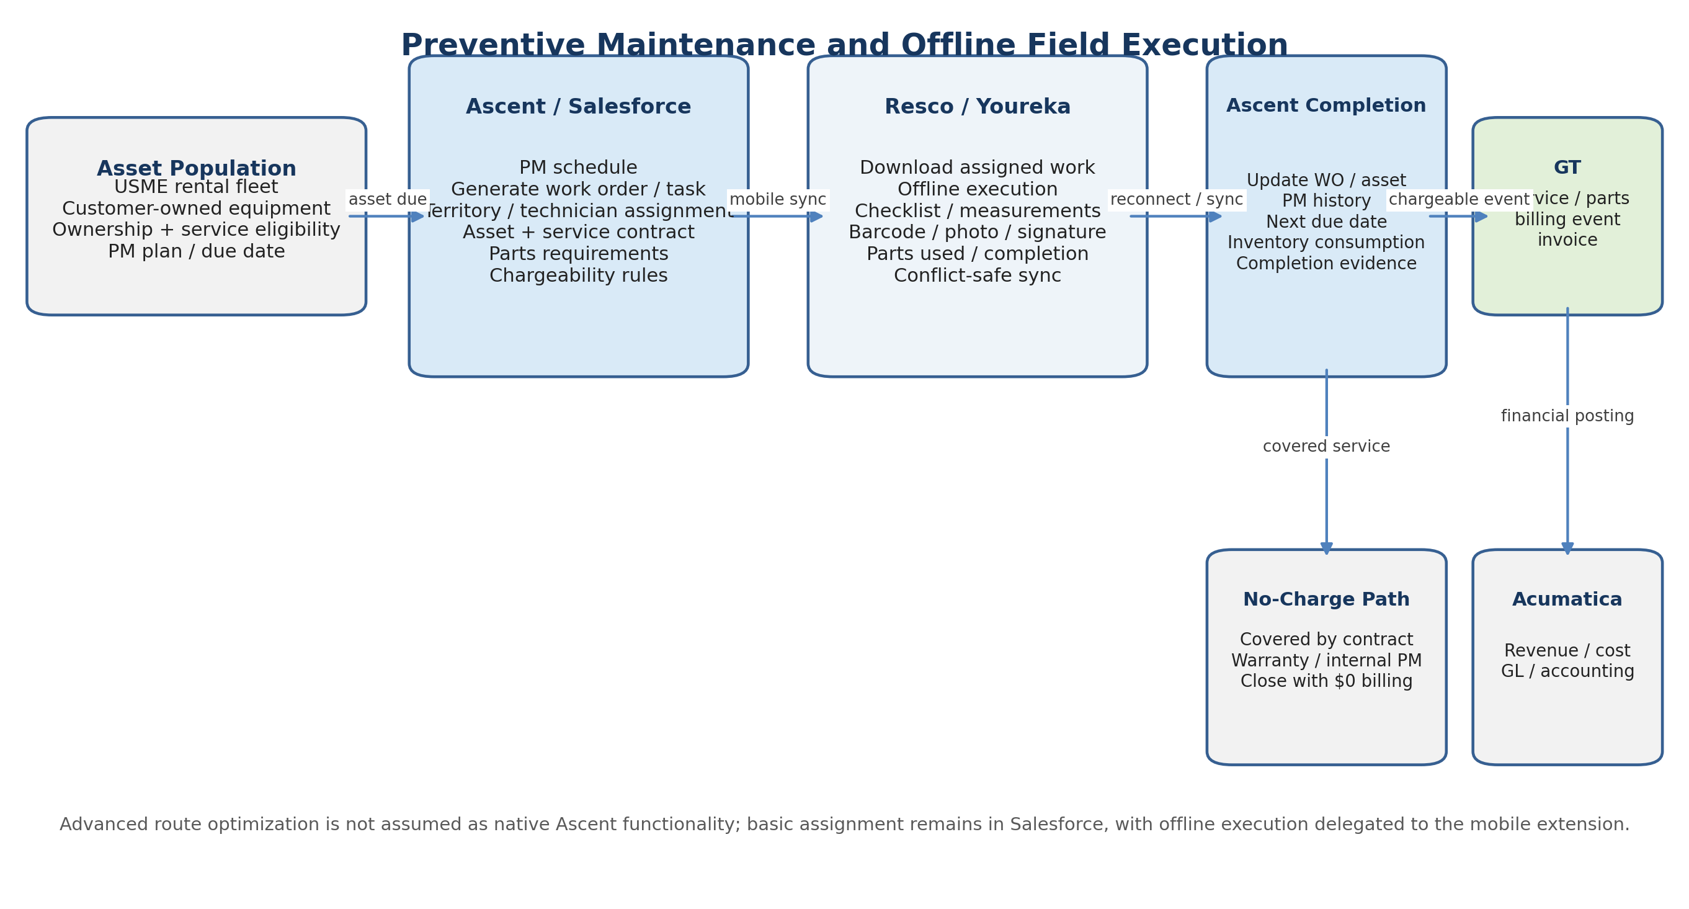
Figure 2. Preventive maintenance and offline work-order execution architecture.
USME needs preventive maintenance for both rental fleet equipment and customer-owned equipment. Both populations should exist in the same Salesforce/Ascent asset model, distinguished by ownership and service entitlement. Customer-owned equipment is not treated as a rental merely to obtain service functionality; it is an installed/serviced asset with its own maintenance plan, warranty/service contract and billability rules.
Capability | Ascent / Salesforce responsibility | Resco / Youreka responsibility
PM planning | Asset ownership, PM interval, last/next due date, maintenance plan, contract/warranty and service location. | Receives only assigned due work and required asset/context data.
Work creation | Generate work order/task, type, priority, location, required parts/checklist and due window. | Download work packet for offline access.
Assignment / dispatch | Baseline territory, regional team and technician ownership; manager assignment. | Present assigned jobs; optional route/mobile UX features if supported by selected product.
Offline execution | System of record for template/checklist definition and eventual results. | Offline checklist, measurements, root cause, repair/inspection result, barcode, photo, signature, notes and parts used.
Synchronization | Validate updates, prevent invalid closure, update asset/service history and inventory. | Queue local changes and synchronize when connectivity returns; expose sync/conflict status.
Completion | Task -> work order -> related case/request closure sequence; schedule next PM. | Capture completion evidence and technician acknowledgement.
Billing | Determine covered/no-charge vs chargeable service and construct canonical service/parts event. | No billing calculation; returns service facts to Ascent.
Security | Shield, sharing, field access, audit and tokenization. | Encrypted device cache, MDM compatibility, remote wipe, short offline-retention window and minimum PHI.

7.1 Rental-fleet PM
- PM schedule is generated from the Ascent serialized asset and maintenance plan regardless of whether the asset is in warehouse, vehicle stock or at a customer location.
- If maintenance can be completed at the customer site, the technician executes the work order offline and synchronizes results. If the business process requires swap/replacement instead of on-site maintenance, Ascent links the PM/service request to the swap process and preserves asset/install-base integrity.
- Parts consumed reduce Ascent inventory and create the appropriate cost/accounting event for Acumatica. Chargeable service or parts create a GT billing event; contract-covered PM closes with no customer charge.

7.2 Customer-owned equipment PM
- Create a customer-owned asset/install-base record with manufacturer/model/serial, owner, service location, maintenance plan, warranty/service contract and billing terms.
- PM due generates a work order and technician assignment in Ascent. The offline mobile extension executes inspection, checklist, repair, signature and completion in the same manner as rental-fleet PM.
- Chargeable labor, fixed-fee maintenance, travel or parts create a service billing event to GT. Customer-owned PM does not create rental activation/termination events.
- The completed work order updates maintenance history and next due date and is available to Experience Cloud only if USME elects to expose service history to that customer.
Design constraint from vendor response. Ascent offline synchronization is not supported natively today, and dispatch optimization is not a native Ascent feature. These are intentionally separated from the Ascent core rather than hidden in custom code. The selected mobile product must prove offline sync, barcode/photo/signature, conflict handling, large work packets and secure device storage in a production-scale POC.

8. Billing Architecture and One-Year Parallel Billing
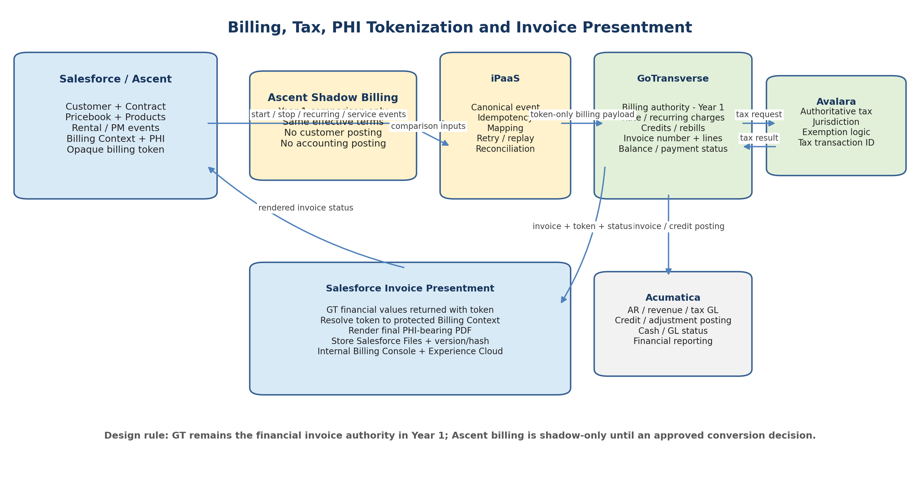
Figure 3. Billing, tax, tokenization and invoice-presentment architecture.

8.1 GoTransverse remains authoritative in Year 1
GT continues to execute billing and produces the legally/financially authoritative invoice values during the first year. Ascent is the source of operational events that affect billing: rental activation, rental stop, recurring rental period, quantity changes, swaps, service/PM, parts, loss, damage, buyout, sale and approved adjustments. The integration layer converts those changes into an idempotent canonical billing event and posts them to GT.
Event type | Source in Ascent | Minimum payload to GT | Primary control
RentalActivated | Explicit rental activation / delivered state | event ID, token, customer/billing key, contract/rate reference, product, qty, effective start timestamp, order/rental ID | Exactly-once effective start; reject duplicate activation.
RentalStopped | Pickup request / approved termination based on business rule | event ID, token, order/rental ID, product, effective stop timestamp, reason | No charges after approved stop date; physical pickup may occur later.
RecurringCharge / Usage | Active rental and billing cadence | token, service period, rate-plan/product mapping, quantity, branch/location, source event ID | No gaps/overlaps; effective-date mapping validated.
RentalChanged / Swap | Mid-rental change or atomic swap | prior/new product or permitted asset reference, effective timestamp, quantity/rate impact, token | Preserve billing continuity and install-base integrity.
Service / PM | Completed chargeable work order | service code, labor/fee, parts, service date, token/account/contract, work-order ID | No invoice if covered/no-charge; prevent duplicate mobile-sync billing.
Loss / Damage / Buyout | Approved exception or conversion | charge type, amount basis/rule reference, asset/order, token, approval ID | Approval and source traceability before billing.
Credit / Adjustment request | Approved billing correction workflow | GT invoice/line reference, reason, amount or reversal instruction, approver | Correction occurs in GT; never overwrite Salesforce invoice values.

8.2 Ascent shadow billing
USME will configure Ascent billing rules in parallel for approximately the first year. The objective is not dual billing; it is controlled evidence that Ascent can reproduce GT results before any later architecture decision. Ascent shadow output must be marked simulation/non-posting and must not create customer-facing invoices, committed Avalara tax transactions, Acumatica AR/GL entries or cash activity.
- Use the same approved Salesforce contract, product, pricebook, effective dates and customer-specific terms as the source for both Ascent and GT configuration.
- Compare at line level: billing period, quantity, rate, proration, discount, service/exception charge, tax basis, tax, credit/adjustment and total.
- Store a Parallel Billing Comparison record or curated Snowflake fact that links Ascent simulation ID, GT invoice/line ID, token/order/rental ID, variance amount, variance type, owner and resolution.
- Classify variances into mapping/configuration, timing/effective date, proration, rounding, tax, missing/duplicate event, credit/rebill, manual override or data quality.
- Finance defines acceptable tolerances and the duration of sustained clean comparison before any decision to retire or reduce GT. A future migration is a governance decision, not an automatic end-of-year cutover.

8.3 Billing-rule ownership
Business-approved contract and pricebook terms are mastered in Ascent/Salesforce. GT remains the Year-1 executable rating engine and may maintain mapped rate plans/products as required by its billing model. The integration design must version mappings by effective date so historical invoices can always be reproduced and explained. Changes to customer pricing should follow a controlled publish process to both GT and the Ascent shadow configuration.

9. PHI Tokenization and Invoice Presentment
Because Ascent is Salesforce-native, operational and PHI data can exist inside the same Salesforce trust boundary; however, PHI should still be separated into protected objects/fields and not copied into rental, inventory, work-order, mobile cache or integration payloads unless necessary. GT, Acumatica and Avalara should operate on non-PHI business data plus an opaque token where patient-specific correlation is required.

9.1 Billing Context and token
- Salesforce creates a protected Billing Context for patient/beneficiary-specific invoice attributes and generates a random, opaque, non-derivable token.
- The token is linked to customer, contract, order/rental episode and approved PHI fields. It must not encode name, DOB, MRN, room number, patient number or predictable sequence.
- Ascent rental/work-order records reference the token where billing correlation is required. Offline mobile receives patient identity only when demonstrably necessary for field execution and role-authorized.
- GT receives the token plus billing facts. Acumatica receives financial/accounting data and invoice references, not patient identity. Avalara receives only the transaction/customer/address/taxability data required for tax calculation.

9.2 Invoice return, rendering and storage
- GT finalizes the invoice and returns invoice ID/number, token, line items, service dates, rates, taxes, credits/adjustments, totals, due date, balance/payment status and document status.
- The integration layer validates the token and customer/order correlation and writes the financial values into Salesforce Invoice Presentment / Invoice Line records as read-only values.
- Salesforce resolves the token internally to the protected Billing Context and combines the approved PHI fields with the immutable GT financial values.
- An approved Salesforce-native or BAA-covered rendering service generates the final PDF. The file is stored in Salesforce Files with GT invoice ID, version, template/renderer version, render timestamp and cryptographic hash.
- Internal billing users access the current and prior versions through a Billing Console. Authorized hospital/facility users access the same approved current version through Experience Cloud.
- Credits, voids and rebills create explicit status/version lineage. Prior PDFs are superseded, not silently overwritten.

9.3 Recommended Salesforce billing objects
Object / record | Purpose | Key fields / controls
Billing Context | Protected PHI-to-token mapping | token, patient/beneficiary reference, account, contract, order/rental episode, permitted invoice PHI, active dates, audit status
Invoice Presentment | Salesforce representation of GT invoice | GT invoice ID/number, customer, token, invoice/status dates, subtotal, tax, total, balance, payment status, current version, portal visibility
Invoice Line | Read-only imported financial line | GT line ID, product/service, service dates, quantity, rate, discount/adjustment, tax, amount
Invoice Document Version | PDF lineage | file ID, version, template/renderer version, hash, rendered timestamp, current/superseded status, reason
Billing Exception | Controlled failure work queue | event/token/invoice reference, exception type, owner, age, root cause, resolution, approval
Parallel Billing Comparison | Year-1 Ascent-vs-GT evidence | Ascent simulation ID, GT invoice/line ID, order/rental, billed attributes, variance, reason, resolution status

10. Acumatica Financial / ERP Integration Architecture
Acumatica remains the accounting and GL system. The design separates operational truth from accounting truth: Ascent knows where the equipment is and what operational transaction occurred; GT knows what was billed; Acumatica determines and records the accounting impact. This avoids using Acumatica as a second rental or billing engine while still maintaining complete financial control.

10.1 Ascent -> Acumatica
Business event | Data sent from Ascent | Acumatica use
Operational purchase order | PO number, vendor cross-reference, items, qty, unit cost, branch/location, expected date, freight estimate, approval status, project/order reference | Create/update PO/commitment for AP and financial control; support three-way match.
Receipt / vendor return | PO/line, received qty, serialized assets where required, receipt date, branch, cost, return reason | Receipt accrual, inventory/fixed-asset accounting, AP match and vendor return accounting.
Asset acquisition / capitalization | asset serial/model, acquisition cost/date, vendor, location, ownership/classification, useful-life class if governed in Acumatica | Create/update fixed-asset or inventory accounting reference where the accounting policy requires capitalization.
Inventory adjustment / write-off | item/asset, qty, location, reason, cost basis, approval | Post inventory variance, shrink, loss, damage or write-off accounting.
Sale / ownership transfer | sales order, asset/item, qty, delivery/ownership date, cost basis, customer reference | COGS / asset disposal and ownership accounting. Revenue still originates from GT invoice posting.
Parts consumption / service cost | work order, part, qty, source location, cost center/branch, chargeable flag | Expense/COGS or inventory issue accounting; reconcile with GT if customer-billed.
Rental-fleet retirement / disposal | asset, retirement date, reason, proceeds/buyout reference if any | Fixed-asset disposal/write-off accounting and GL posting.
Customer / credit reference where needed | legal customer ID, terms/credit status mapping, branch/company | Maintain financial customer cross-reference without copying PHI.

10.2 GoTransverse -> Acumatica
GT transaction | Financial data transferred | Acumatica accounting outcome
Finalized invoice | invoice ID/number, customer, lines or summarized revenue classes, service period, subtotal, tax, total, due date, branch/entity, source order/rental IDs | AR and revenue posting; preserve GT invoice as external document reference.
Credit / void / rebill | original invoice reference, new credit/rebill document, reason, amounts, tax reversal/recalculation | Create explicit credit/debit/reversal accounting; never overwrite prior GL history.
Tax | Avalara/GT tax amount, jurisdiction summary, document code as needed | Sales-tax liability posting; Acumatica does not independently recalculate the authoritative invoice tax.
Payment / cash application - if GT owns | payment ID/date/method, invoice applied, amount, remaining balance | Cash/AR settlement and GL posting.
Balance/status | invoice status, balance, delinquency/hold signal where used | Financial status reconciliation and optional credit-hold feedback to Salesforce.
Billing adjustments | service/adjustment code, amount, effective period, reason/approval reference | Map to designated revenue/contra-revenue/expense accounts.

10.3 Acumatica -> Ascent / GT feedback
- Vendor master/status and approved vendor IDs used by Ascent operational POs.
- PO financial approval/hold status, receipt/AP-match exceptions and financial posting confirmation.
- Customer credit hold/credit status and terms where Acumatica is the financial authority for those controls; Ascent uses the returned status during order validation.
- Fixed-asset/accounting IDs, capitalization/retirement status or book-value references when required for operational-to-financial traceability.
- If Acumatica rather than GT owns cash application, payment/settlement is sent from Acumatica to GT. USME should designate one cash-application authority and avoid bidirectional payment ownership.
Key financial design rule. Do not send the same business event independently from both Ascent and GT into Acumatica. Ascent supplies operational procurement, asset and inventory-cost events; GT supplies billed revenue/AR/tax/credit transactions. The interface catalog must explicitly assign each accounting event to one source.

11. Avalara Sales-Tax Architecture
Avalara should be the central tax-calculation service, with tax policy owned by USME Tax/Finance. Medical equipment rental, sale, buyout, freight, repair/maintenance, parts and loss/damage charges can have different tax treatment by jurisdiction and exemption status. The architecture sends the required transactional facts to Avalara; it does not hard-code tax law in Salesforce or GT.
Stage | Sender / caller | Avalara request data | Result / use
Quote / order estimate | Ascent / Salesforce | legal customer, ship-to/service location, origin, transaction type, product/service tax code, amount/qty, exemption context, date | Estimated tax displayed for quoting/approval; not committed as final invoice tax.
GT invoice preview/finalize | GT or iPaaS on behalf of GT | authoritative invoice lines, service/rental period, customer/account, destination, product/service tax codes, taxable amounts, exemption/certificate reference, freight | Authoritative line/jurisdiction tax returned to GT.
Commit | GT / iPaaS | final invoice/document code and same tax facts | Commit one Avalara transaction tied to the GT invoice number/ID.
Credit / void / rebill | GT / iPaaS | original Avalara/GT document reference and reversal/new transaction facts | Reverse/recalculate tax consistently with GT financial document lineage.
Accounting | GT -> Acumatica | final tax amount and reference | Acumatica posts tax liability; no duplicate tax calculation.
Shadow billing | Ascent | same tax inputs in non-commit/estimate mode or consume GT/Avalara tax result | Allows fair Ascent-vs-GT comparison without creating duplicate Avalara tax documents.

- Product/service tax mapping should distinguish rental, outright sale, buyout, service/PM, labor, parts, loss/damage and freight. Taxability is governed by Finance/Tax, not by technical developers.
- Customer exemption/certificate status must be available to the authoritative Avalara call. If exemption certificates are managed in another tax tool/module, integrate the status rather than duplicating certificate logic in Ascent.
- Do not send patient name, DOB, diagnosis or other PHI to Avalara. Use legal customer and facility/service-address data required for tax sourcing, with the minimum necessary fields.
- Store Avalara document/transaction ID, line tax and jurisdiction summary with the GT invoice/Salesforce presentment record to support reconciliation and audit.

12. Integration Architecture
Although GT, Acumatica, Avalara and other platforms may offer Salesforce connectors, USME should maintain a hub-and-spoke integration architecture through Workato, Boomi or the selected enterprise iPaaS. Native connectors accelerate authentication and mapping but should not create uncontrolled point-to-point business logic. Canonical IDs, idempotency, retries, exception queues and reconciliation should be common across interfaces.
ID | Interface | Direction | Primary content | Pattern / control
I-01 | Experience Cloud <-> Ascent | Native Salesforce | Portal order/pickup/service requests, status, invoices, contacts/entitlements | Same-org sharing and Flow; no external integration.
I-02 | Resco/Youreka <-> Ascent | Bi-directional | Assigned work orders/assets/checklists; offline results, parts, barcode, photo/signature | Mobile sync with conflict handling; completion event generated only after authoritative Salesforce commit.
I-03 | Ascent -> GT | Outbound | Rental start/stop, recurring/service/parts/loss/damage/buyout/sale billing events, token | Event/API; unique event ID, effective timestamp, idempotency.
I-04 | GT -> Salesforce | Inbound | Invoice/line, tax, credit/void/rebill, balance/payment status, token | API/batch; write read-only presentment objects; controlled exception queue.
I-05 | Ascent -> Acumatica | Outbound | POs, receipts/returns, asset/inventory accounting events, parts consumption | API/connector; operational event is source.
I-06 | Acumatica -> Ascent | Inbound | vendor/financial approval, credit hold/status, accounting IDs/post status | API/batch; only needed financial reference data.
I-07 | GT -> Acumatica | Outbound | invoice/AR, revenue, tax, credits/voids/rebills, payments/status per ownership model | Financial interface; reconcile invoice totals and document lineage.
I-08 | GT/Avalara | Bi-directional | tax calculation/commit/credit with product, amount, location, exemption | Synchronous for invoice finalize where feasible; one committed tax doc.
I-09 | Ascent -> Avalara | Outbound estimate | quote/order or shadow-billing tax estimate | Non-commit; must not create duplicate committed tax transaction.
I-10 | Salesforce/Ascent -> Snowflake | Outbound | customer/commercial, order/rental, asset, inventory, work order, PM, portal usage | Incremental/CDC/batch; tokenize/restrict PHI.
I-11 | GT -> Snowflake | Outbound | billing, invoice, credit, balance/payment, rating/variance data | Incremental/batch; preserve invoice lineage.
I-12 | Acumatica -> Snowflake | Outbound | GL, AP, financial PO/receipt, asset/inventory accounting | Incremental/batch; finance-controlled dimensions.
I-13 | Avalara -> Snowflake | Outbound | tax transaction, jurisdiction, exemption/result | Batch/API for tax analytics and reconciliation.
I-14 | Snowflake -> Power BI | Read | certified semantic models and aggregates | Read-only analytics with row-level security.
I-15 | Optional freight provider -> Ascent | Bi-directional | carrier, label, tracking, ETA/delivery status | Only if H7 business need is adopted; vendor response suggests ZenKraft/Bringg-type solution.

12.1 Canonical enterprise identifiers
- salesforceAccountId / facilityId / contractId / orderId / rentalId / workOrderId / assetId
- billingToken for patient-specific financial correlation; no PHI encoded in the token
- gtBillingAccountId / gtInvoiceId / gtInvoiceLineId / ratePlanCode
- acumaticaCustomerId / vendorId / poId / financialDocumentId / fixedAssetId as applicable
- avalaraTransactionId / documentCode
- sourceEventId + correlationId + eventVersion for all cross-system business events

12.2 Reliability patterns
- Persist event processing status (new, posted, rejected, retrying, dead-lettered, cancelled, superseded) outside transient connector logs.
- Use idempotency keys at GT, Acumatica and tax boundaries where supported; otherwise maintain an integration transaction ledger that prevents duplicate side effects.
- Retry only transient failures. Business-validation failures go to an owned exception queue rather than indefinite retry.
- Replay must preserve the original source event ID/effective timestamp and must not generate a second billing or accounting transaction.
- Mask token-resolved PHI from iPaaS job histories, error messages, email alerts and support exports.
- Reconcile source-to-target counts, amounts and critical statuses daily, with tighter intra-day checks for billing activation/termination and mobile sync exceptions.

13. Data and Analytics Architecture
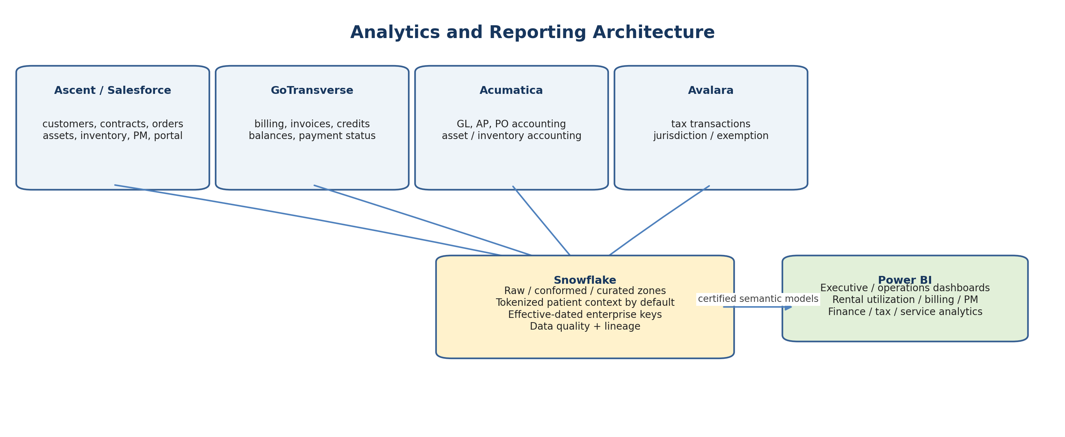
Figure 4. Snowflake and Power BI analytics architecture.
Snowflake is the integration-independent analytical layer. It should retain source-system keys and effective dates so Power BI can analyze the end-to-end commercial-to-rental-to-billing-to-accounting lifecycle without making operational systems query each other. Data ingestion is incremental where possible, with periodic full reconciliation for high-risk facts.
Analytics subject area | Primary source facts | Illustrative Power BI metrics
Commercial / customer | Ascent opportunities, contracts, products/pricebooks, orders | pipeline, conversion, customer/product mix, contract utilization
Rental fleet | Ascent assets, inventory snapshots, rentals, install base, transfers | availability, utilization, turns, branch balance, idle assets, loss/damage
Field service / PM | Ascent work orders + mobile completion | PM due/overdue, first-time completion, cycle time, technician workload, parts use, customer-owned service revenue
Billing | GT invoices, credits, balances, payment status + Ascent events | activation-to-bill latency, stop-bill accuracy, credit/rebill rate, billing exceptions
Parallel billing | Ascent simulation + GT invoice | match rate, variance by rule/product/customer, unresolved variance aging
Finance | Acumatica GL/AP/PO accounting | revenue, margin, AP, asset cost, write-offs, branch P&L
Tax | Avalara transaction/jurisdiction/exemption | tax by state/jurisdiction, exemption usage, reversal/credit reconciliation
Portal | Salesforce/Experience Cloud activity | self-service adoption, order/pickup/service volume, invoice access/disputes

13.1 PHI in analytics
The default Snowflake analytical model should be tokenized and should not ingest direct patient identifiers merely because Salesforce contains them. If a defined business or compliance use case requires PHI analytics, isolate it in a restricted Snowflake database/schema with separate roles, masking policies, logging and approved retention. Power BI semantic models should expose only the minimum necessary patient attributes to authorized audiences.

14. Salesforce Shield and HIPAA Security Architecture
Control layer | Recommended implementation | Architecture effect
Salesforce Shield Platform Encryption | Encrypt selected PHI fields, Billing Context/token mapping, sensitive custom fields and supported Files/data elements using approved key management. | PHI remains protected at rest inside Salesforce; encrypted-field query/search implications are tested before production.
Event Monitoring | Monitor logins, API activity, report/export, file access/download, URI/session activity and other supported events. | Supports privacy/security investigation and anomalous-access detection; export to enterprise SIEM where applicable.
Field Audit Trail | Retain history for critical PHI mapping, contract, price, billing-state and invoice-presentment fields beyond standard history where required. | Supports audit and forensic reconstruction of who changed high-risk values and when.
Data Detect | Discover/classify PHI/PII in Salesforce fields/content and identify data placed outside approved locations. | Supports ongoing data-minimization governance rather than relying only on initial design.
Profiles / permission sets / sharing | Least privilege by sales, rental operations, billing, technician, portal, integration and admin roles; external sharing by authorized account/facility relationship. | Prevents cross-customer portal visibility and limits PHI access to roles with business need.
Experience Cloud security | MFA/identity policy as applicable, account relationship sharing, session controls, invoice-level visibility, download logging. | External users see only authorized orders/assets/invoices; no token map, internal logs or unrelated PHI.
Offline mobile security | Device encryption, MDM/remote wipe, local cache minimization, short retention, app PIN/biometric if supported, no PHI in diagnostics/logs. | Offline capability does not create an unmanaged PHI repository on technician devices.
Integration security | OAuth/service principals, least-privilege scopes, secrets vault, certificate rotation, IP/network controls where supported, masked logs. | Connectors do not become a PHI or credential leakage path.
Non-production | Synthetic/de-identified data, sandbox masking, restricted refresh procedures and vendor support access. | Avoids copying production PHI into development/testing by default.
Contractual/compliance | Validate Salesforce/Experience Cloud/Shield, mobile vendor, iPaaS and any document-generation component under applicable BAA/security terms. | HIPAA architecture is supported by both technical and contractual controls; no product is treated as "HIPAA compliant" by label alone.

15. Reconciliation and Operational Control Architecture
Control | Frequency / trigger | Reconciliation / exception condition | Owner / action
Rental billing events | Near-real-time + daily | Ascent activation/stop/service events with no GT acknowledgement; duplicate/replayed events; effective-date mismatch | Billing integration owner resolves before invoice finalization where possible.
Active rental vs billed subscription | Daily | Ascent active rentals with no active GT billing position; terminated rentals still billing; GT billing with no active Ascent rental | Billing Ops + Rental Ops investigate with source-event trace.
Invoice presentment | Each invoice + daily | GT finalized invoice not present in Salesforce; token unresolved; totals/line count differ; PDF not rendered/portal-visible | Billing exception queue; no customer release until resolved.
Parallel billing | Each billing cycle | Ascent shadow and GT differ by rate, dates, qty, proration, tax, credit or total | Finance-owned variance queue and root-cause category.
Avalara tax | Each invoice + daily | GT invoice tax differs from committed Avalara transaction; missing/duplicate tax document; credit not reversed | Tax/Finance correct through authoritative transaction lineage.
GT -> Acumatica financial posting | Daily / period close | Missing invoice/credit, amount/tax mismatch, duplicate financial document, posting error | Finance integration owner; Acumatica posting status returned.
Ascent PO -> Acumatica | Daily | Approved Ascent PO missing in Acumatica; receipt qty/cost mismatch; cancelled PO still open | Purchasing/AP exception queue.
Asset/install-base integrity | Transaction + daily | More than one active assignment, active rental without asset/install base, returned asset still assigned, swap partially completed | Operations exception queue; atomic correction with audit.
Offline mobile sync | On reconnect + daily | Completed local work not synced, duplicate completion, conflict unresolved, stale mobile cache | Field-service supervisor / mobile support; billing event waits for authoritative commit.
Snowflake ingestion | Daily | Source counts/amounts missing, stale feed, schema drift, late-arriving financial facts | Data engineering; Power BI freshness status visible.

15.1 Financial close controls
- GT invoice totals and credits reconcile to Acumatica AR/revenue/tax postings for the accounting period.
- Avalara committed tax transactions reconcile to GT invoice/credit documents and Acumatica tax liability.
- Ascent operational PO/receipt totals reconcile to Acumatica PO/AP receipt accounting for the period.
- Rental asset acquisitions, disposals, write-offs and sales reconcile between Ascent asset events and Acumatica accounting records.
- Parallel-billing variance reports are reviewed separately from booked financials so Ascent shadow output cannot contaminate close.

16. Environments, Deployment and Data Migration

16.1 Salesforce / Ascent deployment
USME should prefer installing/configuring Ascent in the existing Salesforce org if Ascent supports that deployment and the org passes technical-health, object-collision, namespace, data-volume and security review. This keeps current customer/opportunity/contract history and avoids a new CRM master. If Ascent is supplied only through a separate OEM org or commercial model, the architecture should be re-evaluated because customer/identity/portal and invoice-presentment integration would become materially more complex.

16.2 Environment strategy
Environment | Purpose | Data rule
Development | Ascent/Salesforce configuration, Flow, integration recipes, mobile forms, unit testing | Synthetic data only; no production PHI.
SIT | End-to-end Ascent-GT-Avalara-Acumatica-mobile-Snowflake tests | Production-like volumes, synthetic tokens and de-identified identities.
UAT / Training | Business process, billing, portal, mobile and PM validation | Purpose-built/de-identified test patients; restricted access.
Performance / scale test | 160K+ asset-scale scenarios, high-volume work/rental/invoice events and mobile synchronization | Synthetic high-volume dataset; test API/query limits and large history.
Production | Live operations, PHI, billing and financial interfaces | Approved BAA/security boundary, Shield, monitoring, backup/DR and incident response.

16.3 Migration domains
- Customer/hospital/facility accounts, contacts, opportunities, open quotes/orders and contracts from current Salesforce structures into the target Ascent-aligned data model as needed.
- Product catalog, pricebooks, customer-specific rates, bundles/configuration groups and tax/product mappings.
- Serialized assets, non-serialized inventory, locations, vehicle stock, install-base assignments, active rentals, consignment/standby and open pickups.
- Open work orders, PM plans, customer-owned service assets, maintenance history needed for due-date calculation and audit.
- Operational vendors and open purchase orders required by Ascent; financial vendor/accounting master remains governed in Acumatica.
- Billing Context/token mappings, GT account/subscription cross-references, open billing exceptions and invoice-presentment records/files subject to retention decisions.
- Cross-system identifiers and code maps must be reconciled before cutover; no migration batch is accepted on record count alone when financial/asset relationships are involved.

17. Implementation Workstreams and Sequence
Workstream | Primary outcome
1. Contract/licensing and org architecture confirmation | Confirm Ascent deployment into existing Salesforce org, exact OEM/Platform entitlement for Opportunity/Case/Service features, Experience Cloud, Shield and mobile/iPaaS contractual/security terms.
2. Ascent fit-gap closure and design | Script and demonstrate C3/C4/D2/D4/D7/E6/E10/H7 and other extension/third-party gaps; approve native process model and extension backlog.
3. Canonical data / system-of-record design | Finalize customer, product, pricebook, contract, order, rental, asset/install-base, work-order, token, PO, tax, invoice and financial keys.
4. Ascent core configuration | Commercial lifecycle, rental/sales orders, inventory, assets/install base, warehouse-lite, return/swap, procurement, work orders, PM and role model.
5. Experience Cloud | Hospital/facility identity, entitlements, rental/sale ordering, pickup/service requests, status, invoices and disputes.
6. Offline FSM / PM | Configure Resco/Youreka work packets, offline storage, barcode/photo/signature, PM forms, sync/conflicts and mobile security.
7. GT billing integration | Canonical events, rate/product mapping, start/stop, recurring/service/exception charges, credits/voids/rebills and payment status.
8. Avalara | Tax-code mapping, quote estimate, GT invoice commit, credit/rebill, exemption handling and tax reconciliation.
9. Acumatica | PO/receipt/accounting events from Ascent; invoice/credit/tax/payment posting from GT; vendor/credit/accounting status feedback.
10. PHI / invoice presentment / Shield | Billing Context/token, Shield controls, invoice objects, rendering, Files repository, Billing Console, portal authorization and audit.
11. Snowflake / Power BI | Source ingestion, conformed models, data quality, tokenized analytics and certified Power BI datasets.
12. Migration and cutover | Migrate/transform current Salesforce and rental/asset data, reconcile identifiers, rehearse cutover and rollback.
13. Parallel billing and hypercare | Run GT authoritative billing and Ascent shadow billing, daily reconciliation, variance resolution and controlled stabilization.
14. Year-1 billing decision | After sustained evidence, evaluate whether to retain GT, reduce its scope or migrate billing authority to Ascent through a separate approved business case and cutover plan.

18. Required Proof-of-Concept and Vendor Confirmation Gates
- Ascent licensing: written confirmation that the Ascent-provided Salesforce entitlement supports the exact Account/Contact/Opportunity/Case/Task/API/Flow features used in this architecture, or identify incremental Sales/Service Cloud licensing.
- Single-org deployment: confirm Ascent can be installed into the current Salesforce org without forcing a separate Salesforce tenant/org and document managed-package limits/namespace/object impacts.
- 160K-asset performance: load representative serialized assets plus multi-year rental, movement, work-order and maintenance history; test availability search, allocation, serial lookup, return, swap and bulk/API operations.
- Fulfilment orchestration C3: approved rental order creates linked operational records/work in the expected sequence without orphaned records.
- Dynamic allocation C4 and substitution D7: demonstrate exception, reallocation and approved equivalent-item logic with structured reason codes.
- Offline D4: airplane-mode delivery/pickup/PM workflow through Resco/Youreka with barcode, photo/signature, parts use, completion, reconnect, conflict handling and exactly-once downstream billing event.
- Dispatch D2/E3: demonstrate baseline assignment/territory workflow and document what is not optimized natively so business expectations match the selected solution.
- Swap G7/G8: atomic outgoing/incoming install-base transition, inventory update and billing continuity with no duplicate active assignment.
- Pickup/termination: billing stop effective on the approved business stop date even if physical collection occurs later; delayed/mobile sync must not extend billing accidentally.
- Lost/damage/parts E6/E10: all charge types normalize into the same canonical billing-event pipeline and reconcile to GT invoice lines.
- Sales / buyout / rental-to-own: ownership-transfer sequence waits for required financial confirmation and updates asset/install-base records atomically.
- Avalara: same taxable basis and exemption inputs produce consistent quote, GT invoice and credit/rebill tax treatment without duplicate committed transactions.
- Acumatica: one sample PO/receipt/return and one GT invoice/credit/payment sequence reconcile end-to-end to accounting documents and GL references.
- Invoice presentment: GT invoice returns with token, Salesforce resolves protected context, renders/stores PDF, exposes correctly to Billing Console/Experience Cloud and logs access.
- Shield / mobile security: encryption, audit, external sharing, sandbox masking, offline cache, MDM/remote wipe and log-scrubbing controls validated before PHI production use.

19. Key Risks and Mitigations
Risk | Why it matters | Mitigation
Salesforce license assumption incorrect | Opportunity/Case/Service functionality cited by the vendor may not be included in the Ascent-provided entitlement. | Contractual entitlement matrix; retain targeted Sales/Service Cloud licenses rather than recreating standard Salesforce capability.
Ascent extensions grow into a custom platform | C3/C4/D7/E6/E10 and specialized flows contain extension/custom elements. | Native-fit governance, architecture review, scoped Flow-first extensions, regression suite and upgrade-impact ownership.
Offline sync creates duplicate billing | Mobile completion may replay or conflict after reconnect. | Generate billing event only after Salesforce authoritative commit; unique completion/event ID; idempotent GT processing and sync exception queue.
Dispatch expectations exceed Ascent | Vendor response states no native dispatch feature. | Baseline territory/assignment in Ascent; document operating process; add advanced FSM only if quantified need justifies it.
Dual billing contaminates financials | Ascent shadow and GT could both post invoices/tax/accounting. | Hard technical flags and interface rules: only GT can commit invoice/tax/GL in Year 1.
Tax mismatch between Ascent and GT | Different tax calls can create false billing variance or duplicate Avalara documents. | One Avalara policy/mapping; GT commits; Ascent estimates/non-commit or consumes authoritative tax result.
Operational and accounting events double-post | PO/inventory events and invoices may be sent from multiple sources to Acumatica. | Explicit event-source matrix: Ascent for operational cost/PO; GT for billed revenue/AR/tax; reconcile document IDs.
PHI spreads through Salesforce-native objects/mobile | Native platform convenience can encourage copying patient data widely. | Protected Billing Context, token/minimum-necessary pattern, Shield, field access, mobile cache limits, Data Detect and log controls.
160K-asset scale not demonstrated | Storage may be easy while availability search/history/mobile/API loads become slow. | Production-scale POC with multi-year history and measured SLAs before cutover.
Snowflake becomes an uncontrolled PHI copy | Analytics ingestion may replicate sensitive fields by default. | Tokenized curated layer by default; restricted PHI schema only with approved use case, masking, role controls and audit.

20. Final Recommendation
Adopt Ascent Rental as the Salesforce-native operational core and deliberately use the native-platform advantage to consolidate customer/commercial, rental, asset, inventory, warehouse-lite and basic work-order functions rather than preserving the prior Salesforce-to-external-rental boundary. Use Experience Cloud as the external channel and Resco/Youreka as the offline execution layer. Keep GoTransverse as the authoritative billing engine during the first year while running Ascent billing in a controlled shadow mode. Use Avalara as the single tax engine, Acumatica as the accounting/GL platform, and Snowflake/Power BI as the analytical layer.
The architecture is viable provided USME closes the specific vendor-fit and licensing gaps identified in the Ascent response. The highest-priority gates are the exact Salesforce entitlement bundled with Ascent, offline mobile synchronization, baseline versus advanced dispatch expectations, fulfilment/dynamic-allocation extensions, consolidated exception charging, and 160K-asset performance. These should be proven through scripted demonstrations and production-scale testing rather than accepted as design assumptions.
For PHI, Salesforce should remain the protected system boundary: use Shield, keep the Billing Context/token map restricted, send token-only patient correlation to GT, avoid patient identity in Acumatica/Avalara/integration logs, and render/store the final PHI-bearing invoice in Salesforce for both internal Billing Console and authorized Experience Cloud access. This preserves the earlier architecture's strongest control pattern while simplifying the operational application landscape around a single Salesforce-native rental platform.

Appendix A. Ascent Fit-to-Architecture Traceability
Ref | Vendor fit / statement | Architecture disposition
C1-C2 | Config | Implement rental initiation and validation in Ascent/Salesforce using Configuration Groups, Flow/validation and controlled override rights.
C3 | Extend / roadmap | Treat fulfillment orchestration as an explicit implementation extension and POC gate.
C4 | Partial | Standard reservation plus scoped invocable/Flow reallocation and exception handling.
C5 | Config | Use Ascent Lightning Warehouse Mobility / mobile flow for online delivery; offline path through selected mobile extension.
C6 | Standard | Authoritative RentalActivated trigger to GT.
C7 | Standard / Config | GT remains billing authority; Ascent billing configured for shadow comparison.
C8 | Standard / Config | Use standard mid-rental process plus controlled config; event impact normalized before GT.
C9 | Standard | Authoritative rental stop/return trigger; business stop date preserved.
C10-C12 | Standard / Config / Portal | Use customer-specific rental locations, standard sub-types and Experience Cloud channel.
D1-D3 | Standard / Config | Ascent work orders/tasks + Salesforce roles/ownership/Flow; no assumption of advanced dispatch.
D4 | Config / Custom; offline not supported | Use Resco/Youreka for offline work, sync, barcode/photo/signature; Ascent remains system of record.
D5-D6 | Standard / Config | Grouped signature and vehicle/truck-stock location supported/configured.
D7 | Custom | Scoped equivalency/substitution extension with reason codes.
D8-D9 | Config | Field exception and protected clinical-context screens configured; PHI minimized on mobile.
E1-E5 | Standard / Config | Pickup/return flow in Ascent; simple territory assignment; bundle validation standard.
E6 | Custom | Lost-equipment extension feeds canonical charge pipeline.
E7-E9 | Standard / Config | Damage inspection, buyout and return lifecycle remain in Ascent.
E10 | Standard / Custom | Normalize loss/damage/parts into canonical GT billing event model.
E11 | Standard / Config | Deferred barcode reconciliation in Ascent Lightning Warehouse / mobile design.
H1 | Standard Salesforce Opportunity | Target Ascent/Salesforce commercial lifecycle; confirm license entitlement.
H2-H6 | Standard / Config / targeted custom | Sales order, validation, fulfillment, PO and internal inventory in Ascent; PO/receipt financial interface to Acumatica.
H7 | Third party | Optional freight/shipping connector (e.g., vendor-recommended ZenKraft/Bringg class) only if required.
H8 | Standard / Config | Inspection work order supports biomedical/clinical processing.
H9 | Standard / Config external billing | Stage billing facts to GT; GT returns authoritative invoice.
H10-H13 | Standard / Config / Extend | Controlled ownership-transfer, buyout, rental-to-own and specialized fulfillment with Flow/extension and financial confirmation.
G1-G3 | Salesforce-native | Case/request and work-order handoff remains in Salesforce; confirm Service Cloud/Case entitlement.
G4-G6 | Standard / configured | Inspection, repair, parts consumption and failed-repair routing in Ascent; offline execution delegated to mobile extension.
G7-G8 | Core + configuration | Atomic equipment swap and install-base integrity are core operational controls.
G9 | JunoDoc / existing / direct flow | Capture signature through selected mobile/e-signature path and enforce task -> WO -> case closure sequence.

Appendix B. Illustrative Tokenized Billing Event
{
"eventId": "ASC-EVT-804421",
"eventType": "RentalActivated",
"eventVersion": "1.0",
"eventTimestamp": "2026-08-20T14:23:51Z",
"correlationId": "SF-ORD-00018422",
"sourceSystem": "ASCENT",
"billingToken": "BCTX-7F4C9A8E-21D6",
"salesforceOrderId": "801xx0000018422",
"rentalId": "RNT-938442",
"customerAccountId": "001xx000001044",
"productCode": "BED-THERAPEUTIC-01",
"ratePlanCode": "HOSP-RENTAL-DAILY",
"quantity": 1,
"serviceStart": "2026-08-20T09:23:00-05:00",
"currency": "USD"
}
Illustrative only. Final field names, event types, API contract and PHI constraints must be agreed across Ascent, GoTransverse, Avalara, Acumatica and the selected iPaaS. Free-text PHI is not permitted in the event payload.

Appendix C. Parallel Billing Comparison - Minimum Data Set
Field group | Illustrative attributes | Purpose
Identity | Ascent simulation ID, GT invoice/line ID, Salesforce order/rental ID, billing token | Trace both calculations to the same business episode.
Service period | billing period start/end, activation/stop timestamp, proration basis | Explain timing and partial-period variance.
Commercial terms | product/service code, rate plan, pricebook/contract version, qty, unit/rate | Prove both engines used the same approved terms.
Amounts | gross, discount, adjustment, taxable basis, tax, credit, line total, invoice total | Line-level and invoice-level variance.
Tax | Avalara transaction/estimate reference, tax code, exemption status, jurisdiction summary | Separate billing-rule variance from tax variance.
Variance | amount, percentage where useful, category, tolerance status | Automated triage and management reporting.
Resolution | owner, root cause, configuration defect, corrected system, retest date, approved close | Evidence for Year-1 billing-engine decision.

Appendix D. Architecture Assumptions Requiring Written Confirmation
- Ascent Rental can be deployed in the current Salesforce org or an equivalent single-org model without requiring a separate CRM/rental Salesforce tenant.
- The Ascent commercial package includes the Salesforce platform/OEM entitlements required for the stated target users; any Opportunity, Case, Service Cloud or other standard-object limitations are identified before license rationalization.
- Experience Cloud is separately licensed and can expose Ascent managed-package records/actions needed for ordering, pickup/service and invoice access under the required sharing model.
- Resco/Youreka can update the required Ascent managed-package/work-order objects offline, synchronize safely, support barcode/photo/signature and meet mobile security requirements.
- GT APIs support all required invoice, credit, void, rebill, balance/payment and idempotent billing-event patterns and can operate with token-only patient correlation.
- Acumatica integration supports the required PO/receipt, financial posting, customer/vendor, asset/inventory accounting and status interfaces without creating a competing operational rental model.
- Avalara integration supports quote/non-commit calculations and one authoritative committed transaction tied to the GT invoice/credit lifecycle.
- Salesforce Shield and the exact Salesforce services used for PHI are covered under approved contractual/security terms, and the selected PDF/mobile/iPaaS components meet corresponding requirements.
- Snowflake/Power BI ingestion can be implemented with tokenized data by default and a separately governed PHI analytical zone only where approved.
Source basis: USME Target Architecture Recommendation Detailed; Functional Requirements Vendor Assessment; Additional information.docx; Ascent vendor fit response "Rental System Requirements_vDRAFT (1).docx" (August 2026). Vendor statements are treated as design inputs and must be contractually/technically validated during implementation.

